22BCA136 **Practical-practice assignment**

**Instructions**

1. write a code to calculate the slope between two point
2. Complete the code segment to swap two numbers using call by object reference.
3. *import* java.util.Scanner;  
     
   *public class* Slop {  
    *public static void* main(String[] args) {  
    Scanner s = *new* Scanner(System.***in***);  
     
    System.***out***.print("Enter x1: ");  
    *double* x1 = s.nextDouble();  
    System.***out***.print("enter y1: ");  
    *double* y1 = s.nextDouble();  
     
    System.***out***.print("Entr x2: ");  
    *double* x2 = s.nextDouble();  
    System.***out***.print("Enter y2: ");  
    *double* y2 = s.nextDouble();  
     
    *if* (x2 - x1 == 0) {  
    System.***out***.println("no slop");  
    } *else* {  
    *double* slope = (y2 - y1) / (x2 - x1);  
    System.***out***.println("slope(" + x1 + ", " + y1 + ") and (" + x2 + ", " + y2 + ") is: " + slope);  
    }  
     
    }  
   }

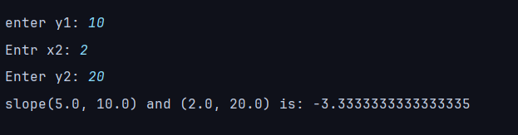

*class* Number {  
 *int* value;  
  
 Number(*int* value) {  
 *this*.value = value;  
 }  
}  
  
*public class* Swap {  
  
 *public static void* swap(Number a, Number b) {  
 *int* temp = a.value;  
 a.value = b.value;  
 b.value = temp;  
 }  
  
 *public static void* main(String[] args) {  
 Number num1 = *new* Number(10);  
 Number num2 = *new* Number(20);  
  
 System.***out***.println("befor swap:");  
 System.***out***.println("num1 = " + num1.value);  
 System.***out***.println("num2 = " + num2.value);  
  
 *swap*(num1, num2);  
  
 System.***out***.println("after swap:");  
 System.***out***.println("num1 = " + num1.value);  
 System.***out***.println("num2 = " + num2.value);  
 }  
}

